Android

Android is one of the most used mobile operating system. It has close to 88% of the market of all smartphones.

Previous versions :

* Kitkat 4.4 - 4.4.4
* Lollipop 5.0 - 5.1.1
* marrshmallow 6.0 - 6.0.1
* Nougat 7.0 - 7.1.2

The newest version of Android is Oreo 8.0

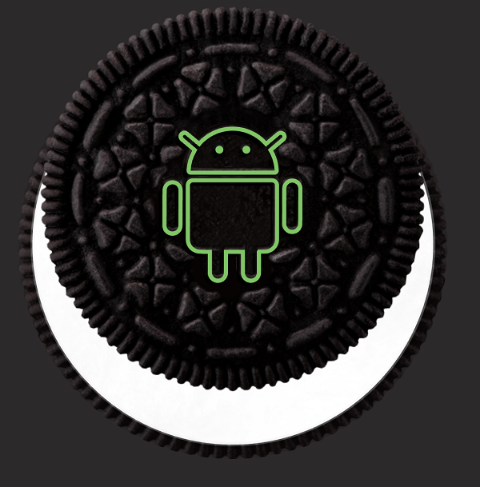

Android also has one the largest range of application on the on the market with over 2 million applications to choose from.

Ios

Apple uses Ios to power their mobile technology which includes IPhone, IPad and IPod touch.

At the moment apple is using Ios 11 which was released last September. Apple are the second most popular after Android.

Apple has also been praised for incorporating thorough accessibility functions into Ios, enabling users with certain disabilities to have a good user experience.

Below are some facts about Apple's new flagship phone :

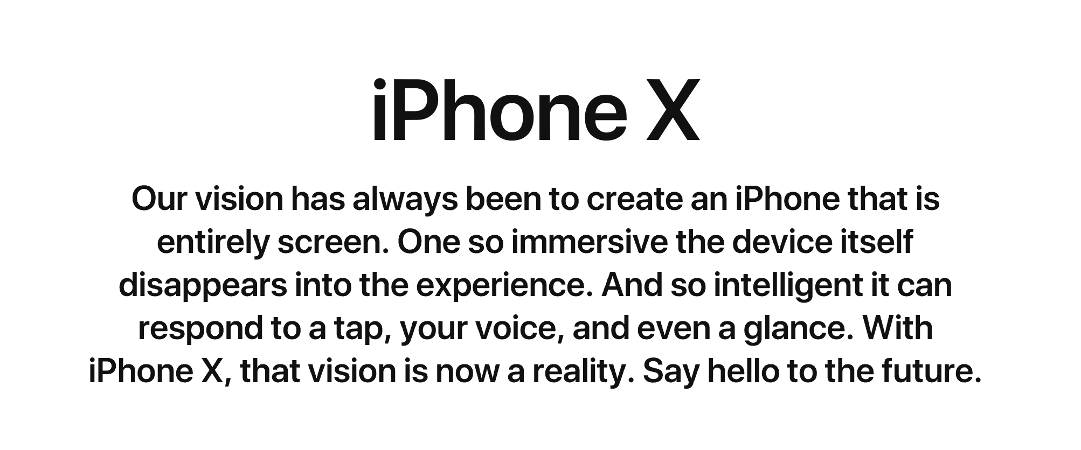

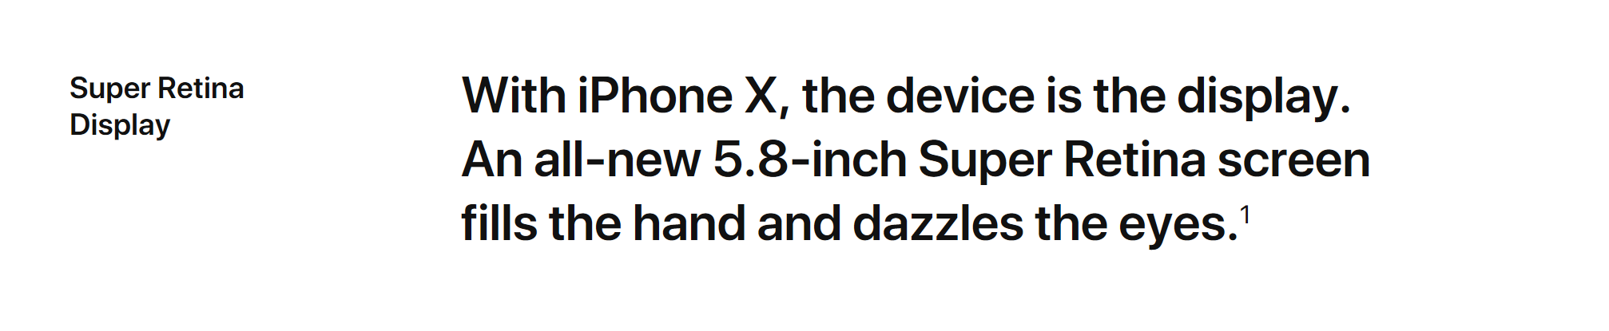

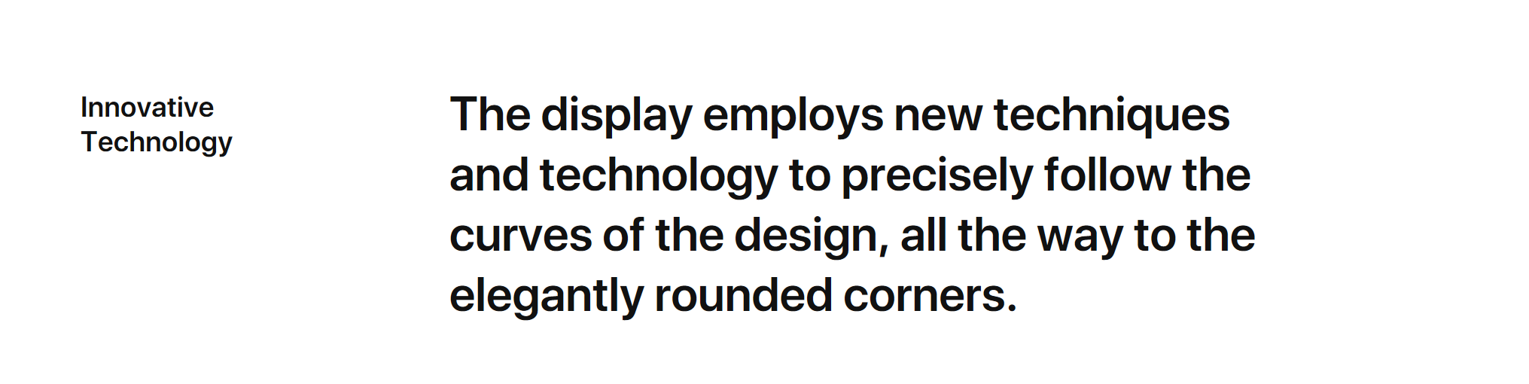

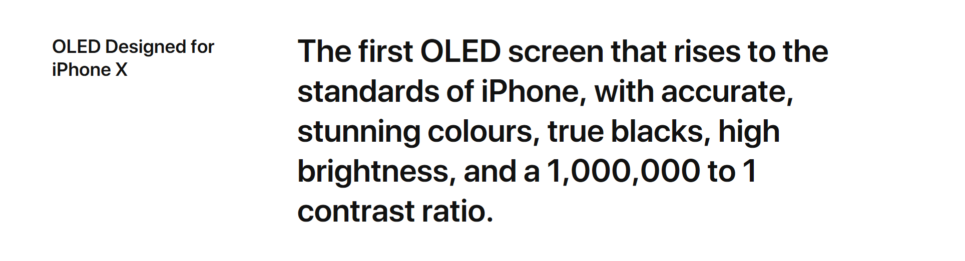

Web Applications

I am going to break down what I believe are the main points of a web application.

1. Reliable - The web application needs to load instantly and automatically detect what type of hardware is being used by the user.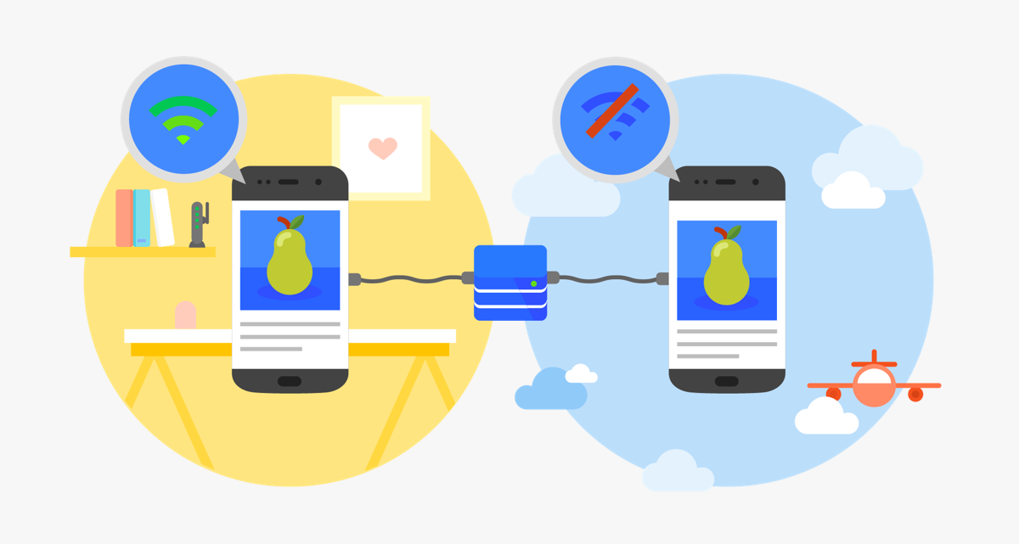
2. Fast - “53% of all users will abandon a site or application if it takes longer than 3 seconds”. Users expect everything to load and appear smoothly. If a user has a bad experience with an application more than likely they will never use it again.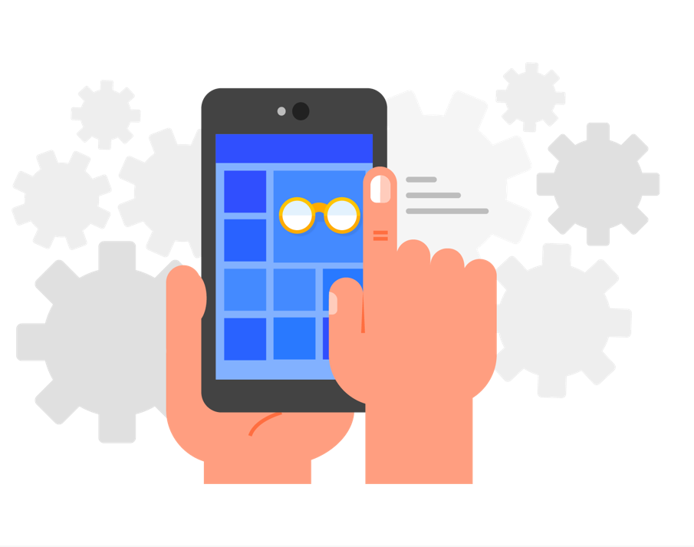
3. Engaging - A web application can be installed on the user's homepage without the use of a app store. The application most provide an immersive full screen experience.

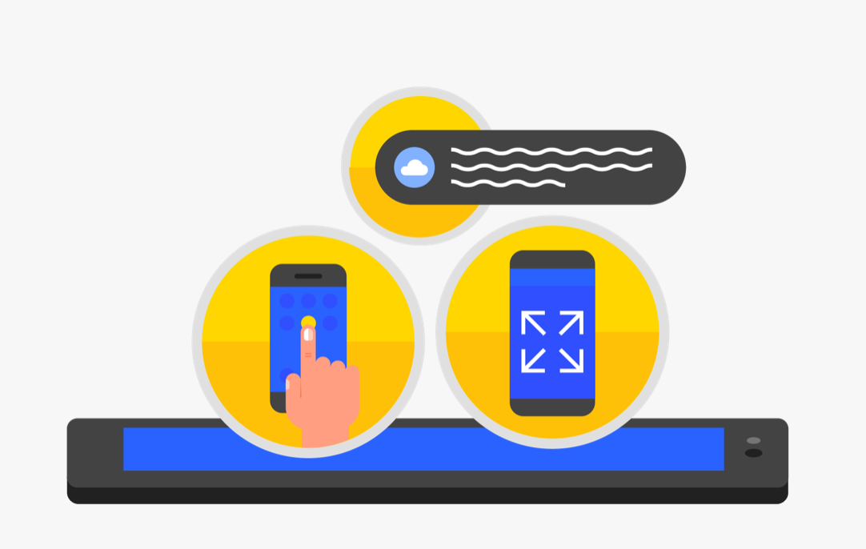

Ref 88% <https://qz.com/826672/android-goog-just-hit-a-record-88-market-share-of-all-smartphones/>

Version

<https://en.wikipedia.org/wiki/Android_version_history>

Iphone os

<https://en.wikipedia.org/wiki/IOS>

Iphone images

<https://www.apple.com/ie/iphone-x/>

Web apps

<https://developers.google.com/web/progressive-web-apps/>